Call number searching
To search by call number in Voyager open the search window (click on the icon). Call number searches may be either Browse or Find. Procedures recommend which to use in specific circumstances.

Browse search (“shelflist” format)

In the Search box, click the radio button next to "Browse." Select "Call number" from the list of search types. In the Locations Filter box highlight the code for the library location from which you are transferring books. To find the right location, scroll past everything in the list that begins with a capital letter. The code for Firestone stacks is f, for Forrestal Annex anxa, and for Fine Annex anxb. Finally type the first part of the call number of your first book in the Search for box and do the search. Then click on the Do Search button, or press Enter.

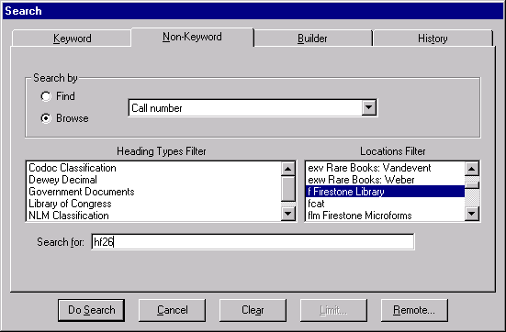

The search result puts you in a continuous list of all call numbers in the location, at the point nearest to the data in your search. From this list you can look for each item with a similar call number. Scroll through the list using arrow keys or the middle two arrows on the display. Do not use the outside two arrows, as they take you to the beginning or end of the list!
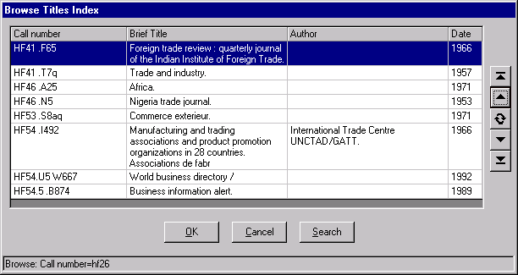

Don’t use these arrows!

Find search

Choose the Find radio button and enter as much of the call number as will be useful. It’s not necessary to enter the entire string. This search can be filtered by location using a different technique.

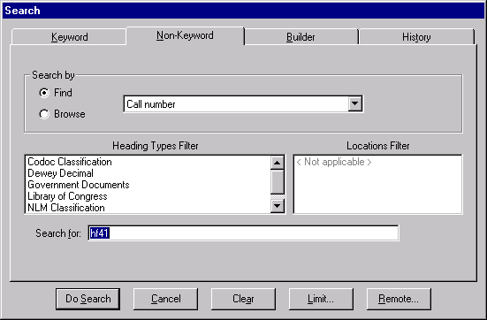
The result is a finite list of matches—12 in this case, as shown below.
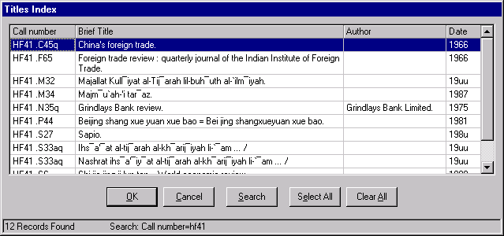
Use the scroll bar or arrow keys to move through the list.

Call number search problems.

Sometimes a call number will not appear in the browse title index where you would expect to find it. Don't give up! Set the book aside and when you've finished work on all the records which do appear in the index, try the techniques below to find the ones which were set aside. If you still don't find a record after that, mark it as "No record found" on the Transfer Problem Form.

Call numbers including a lower case "x"

example: P40
.xI5

The small "x" is ignored when books are shelved, so P40.I48 and P40.xI5 will be near each other on the shelf. In a call number search in Voyager, the "x" will be included in the call number so it will appear farther down in the sequence.

Shelving sequence Browse Titles Index

P40.H3 P40.H3
P40.xI5 P40.I6
P40.H3 P40.H3
P40.I6 P40.xI5
P40.Z33 P40.Z33
Call numbers consisting solely of numbers with a date at the end.

Examples:

2274
.05
.389
1980
2274
.05
.389
.1911

Call numbers consisting solely of numbers which have a date at end may or may not have a period before the date on the call number label. The Voyager record will not necessarily match the call number label, but it also will sometimes have a period before the date and sometimes it will not. If there are several call numbers which are identical except for the date, the browse title index in Voyager will list the call numbers without periods first, then it will list those with periods. You can either scroll down the list until you find your number, or search for the specific call number including a period before the date.

Call numbers with two cutter numbers

example: HF1500
.5
.U5Z36
1998

In the example "Z36" is the second cutter number.

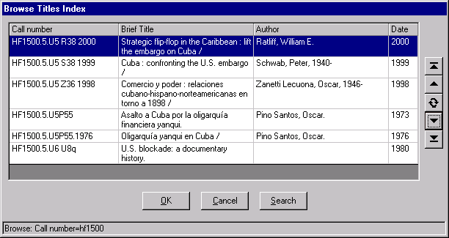
When searching for a call number with two cutter numbers, generally leave a space before the second cutter. However, some records in Voyager lack the space which should appear before the second cutter number. This causes all the call numbers beginning HF1500.5.U5 with the space to list first, followed by those without the space marker. You can either scroll down the list until you find your number, or search the specific call number by searching without a space.

